**Worksheet 1.1**

**Student Name:** Sahil Kaundal **UID:** 21BCS8197

**Branch:** CSE (Lateral Entry) **Section/Group:** 20BCS-809_A

**Semester:** 4th **Date of Performance:** 19/02/2022

**Subject Name:** Programming in Python Lab **Subject Code:** 20CSP-259

**1. Aim/Overview of the practical:**

* Write a program to enter two numbers and perform all arithmetic operations.
* Write a program to enter marks of five subjects and calculate total, average and percentage.
* Write a program to enter length in centimetre and convert it into meter and kilometre, and also convert the same into Equivalents

**2. Task to be done/ Which logistics used:**

* Program to enter two numbers and perform all arithmetic operations.
* Program to enter marks of five subjects and calculate total, average and percentage.
* Program to enter length in centimetre and convert it into meter and kilometre, and also convert the same into Equivalents

**3. Steps for experiment/practical/Code**

* #Program to enter two numbers and perform all arithmetic operations.

#store input numbers:

num1 = input('Enter First Number:')

num2 = input('Enter Second Number:')

#Add two numbers

sum= float(num1) + float(num2)

#Subtract two numbers

sub = float(num1) - float(num2)

#Multiply two numbers

mul = float(num1) * float(num2)

#Divide two numbers

div = float(num1) / float(num2)

#Display the sum

print('The sum of {0} and {1} is {2}'.format(num1, num2, sum))

#Display the subtraction

print('The subtraction of {0} and {1} is {2}'.format(num1, num2, sub))

#Display the multiplication

print('The multiplication of {0} and {1} is {2}'.format(num1, num2, mul))

#Display the division

print('The division of {0} and {1} is {2}'.format(num1, num2, div))

* #Program to enter marks of five subjects and calculate total, average and percentage.

microprocessor = float(input("Please Enter Microprocessor Marks: "))

python= float(input("Please Enter Python Marks: " ))

computer = float(input("Please Enter Computer Marks: "))

IOT = float(input("Please Enter IOT Marks: "))

networks = float(input("Please Enter Networks Marks: "))

total = microprocessor + python + computer + IOT + networks

average = total/5

percentage = (total / 500) * 100

print("TOTAL Marks = % 2f" %total)

print("Average Marks = % 2f" %average)

print("Marks Percentage = % 2f" %percentage)

* #Program to enter length in centimetre and convert it into meter and kilometre, and also convert the same into Equivalents

print(" Enter the Length in Centimeter: ")

c, m , k = float(input()) , 0 , 0

# c = centimeter

# m = meter

# k = kilometer

# Convert centimeter into meter and kilometer

m = (float) (c / 100)

k = (float) (c / 100000)

#Output

print (" Length in Meter = " , m , " meter " )

print (" Length in Kilometer = " , k , " kilometer " )

Kilometer=int(input("Enter the Length in Kilometer:"))

# convert Kilometer to cm

centimeter = 100000 * Kilometer;

print("The Length in Centimeter",round(centimeter,2))

meter=int(input("Enter the Length in Meter:"))

# convert meter to centimeter

centimeter = 100 * meter;

print("The Length in Centimeter is",round(centimeter,2))

1. **Result/Output/Writing Summary:**

* Program to enter two numbers and perform all arithmetic operations.

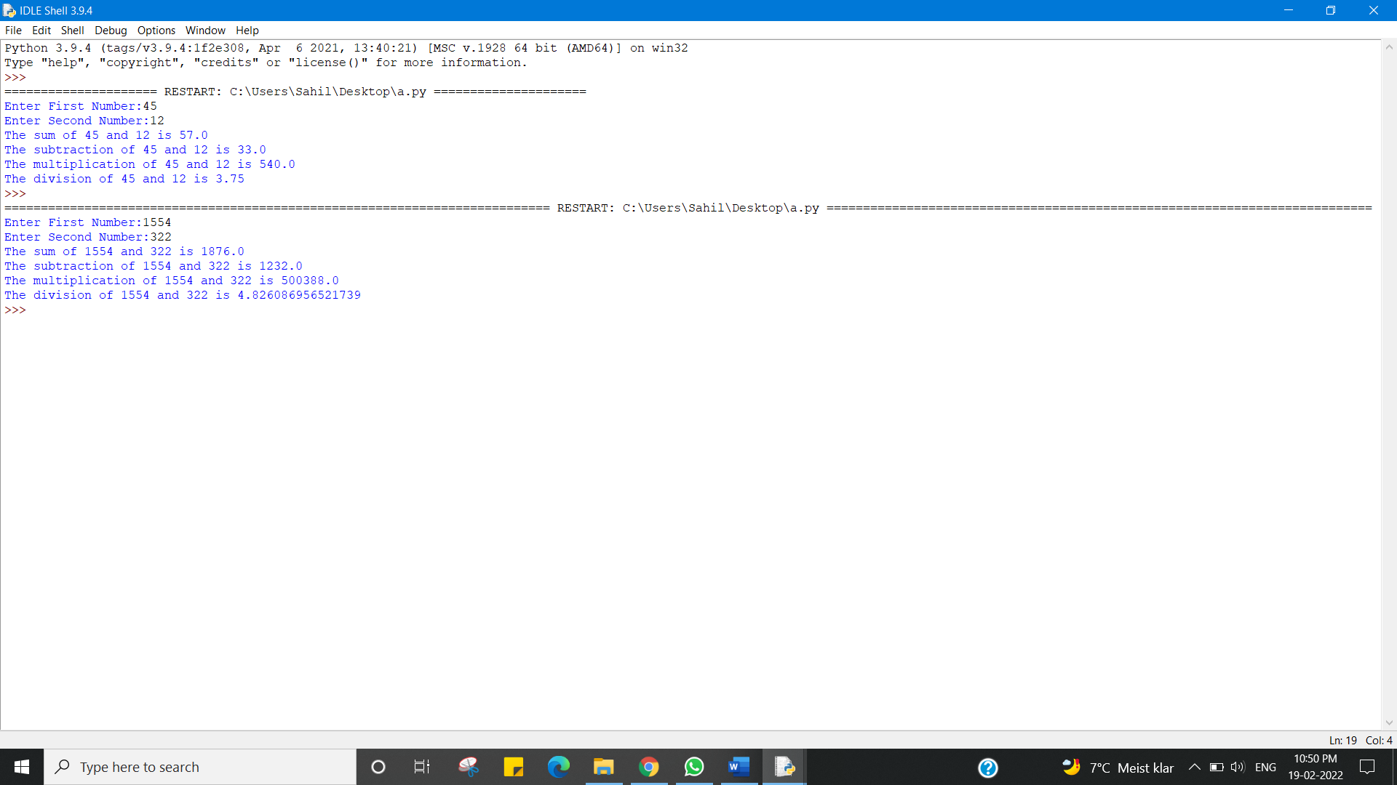

* Program to enter marks of five subjects and calculate total, average and percentage.

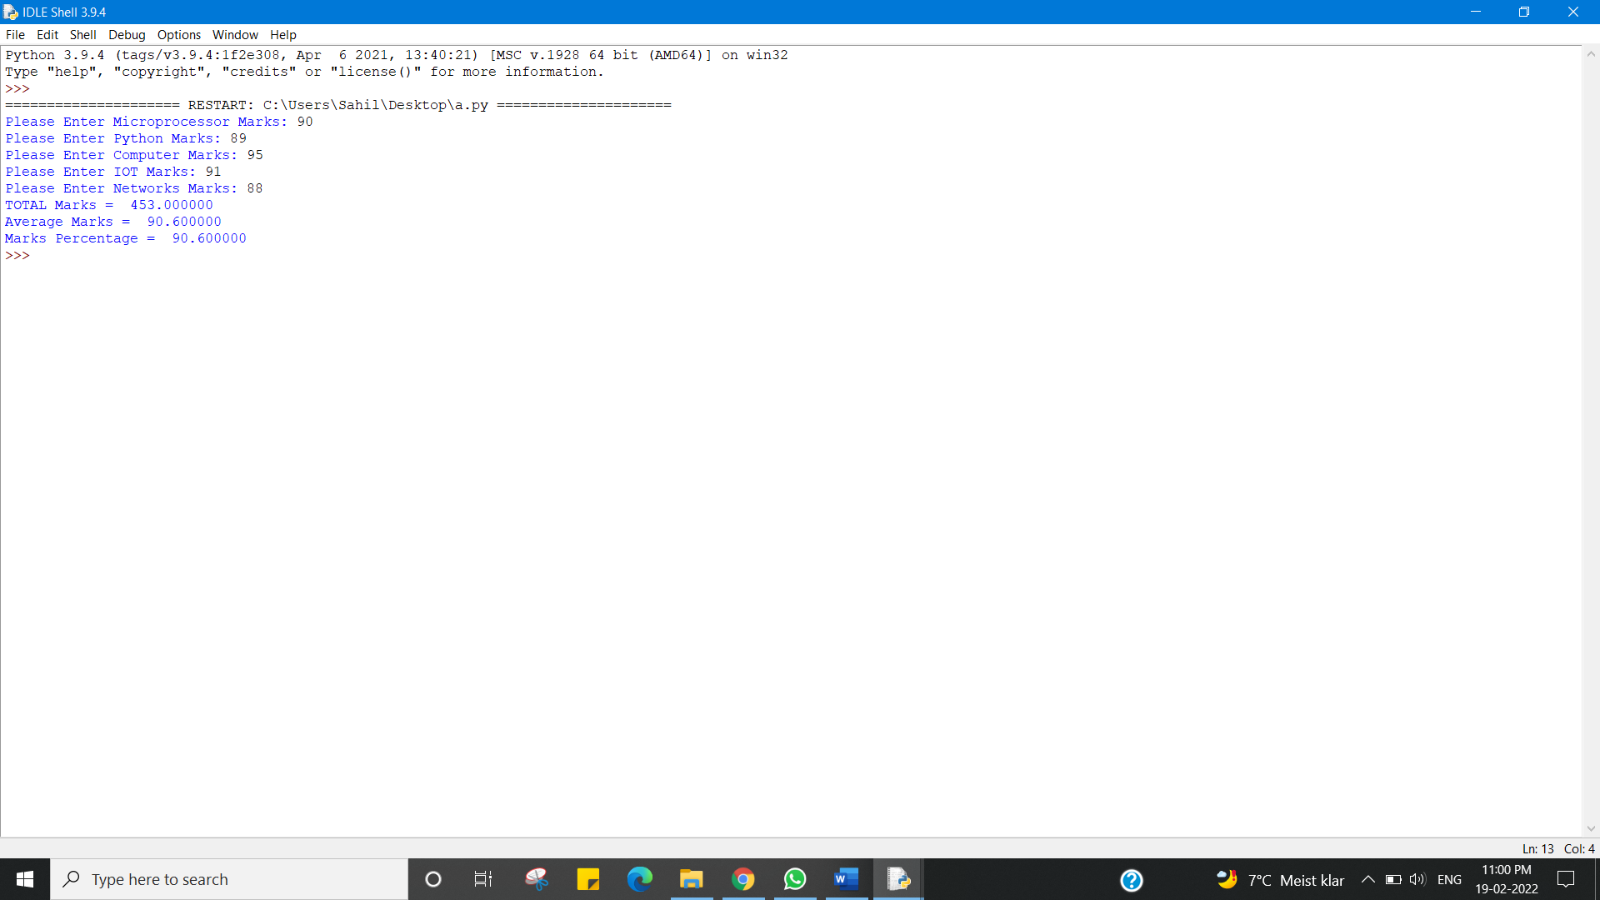

* Program to enter length in centimetre and convert it into meter and kilometre, and also convert the same into Equivalents

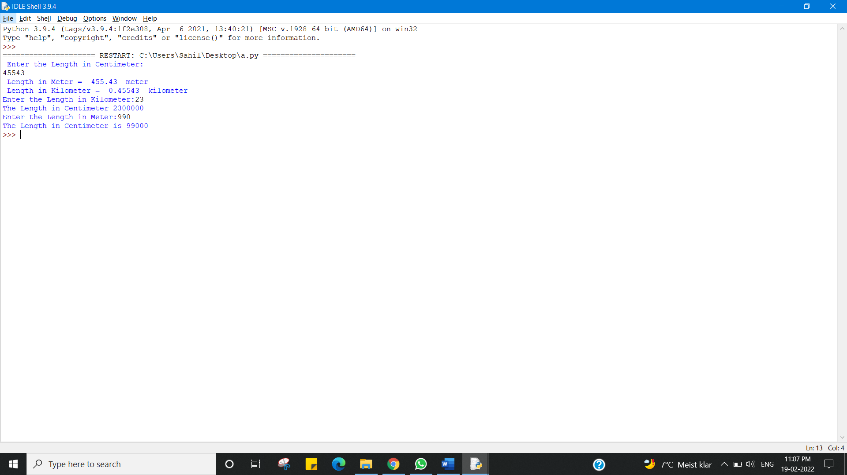

**Learning outcomes (What I have learnt):**

1. Program to enter two numbers and perform all arithmetic operations.

2. Program to enter marks of five subjects and calculate total, average and percentage.

3. Program to enter length in centimetre and convert it into meter and kilometre, and also convert the same into Equivalents

**Evaluation Grid (To be created as per the SOP and Assessment guidelines by the faculty):**

|  |  |  |  |
| --- | --- | --- | --- |
| Sr. No. | Parameters | Marks Obtained | Maximum Marks |
| 1. |  |  |  |
| 2. |  |  |  |
| 3. |  |  |  |
|  |  |  |  |